**Steps 1: Make freestyle project:**

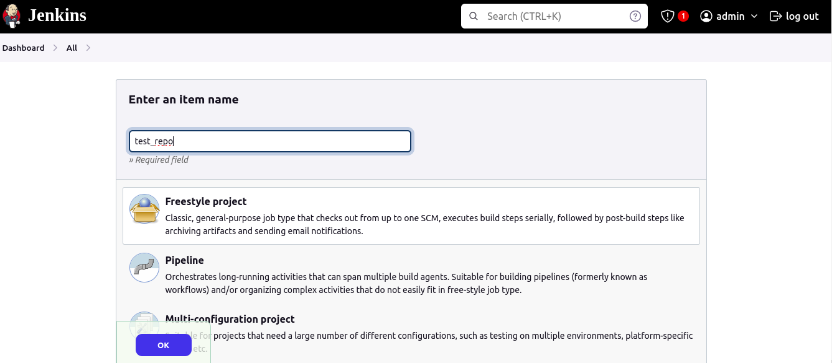

**Step 2: Add the Git Repository from where we have to fetch the code.**

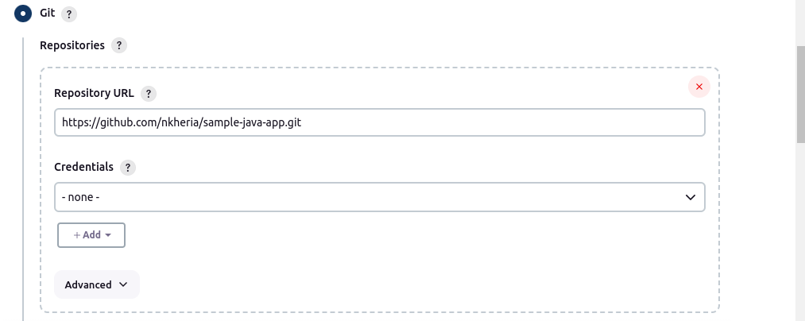

**Step 3: Choose the branch where your code is present**

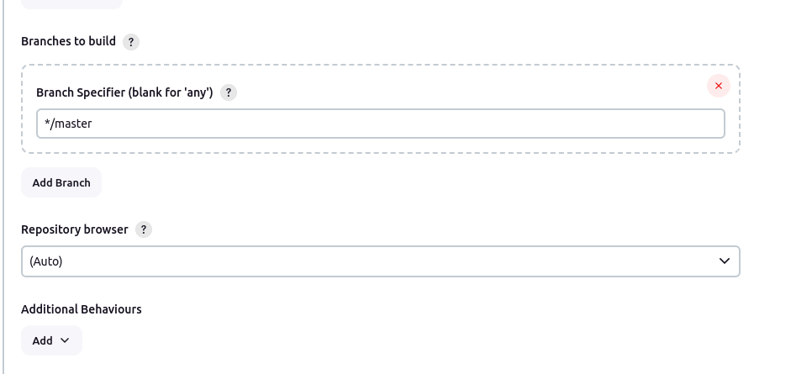

**Step 4: Add the cronjob is you want to run file in every 2 minutes**

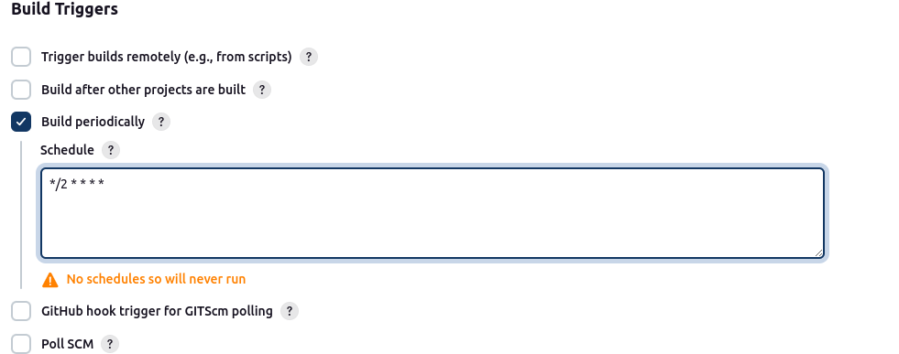

**Step 5: Add the commands in Build steps to run java program**

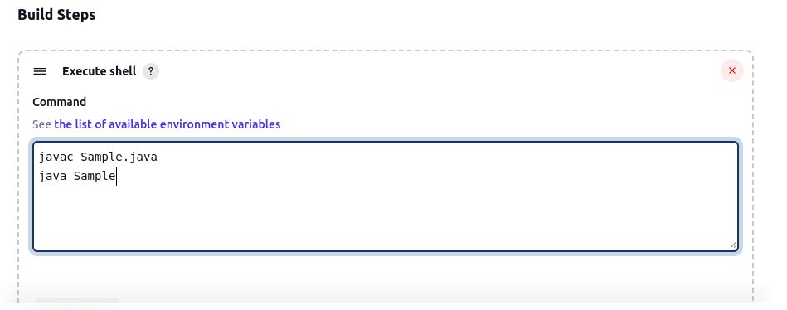

**Step 6: Here the pipeline is running properly in every 2 minutes:**

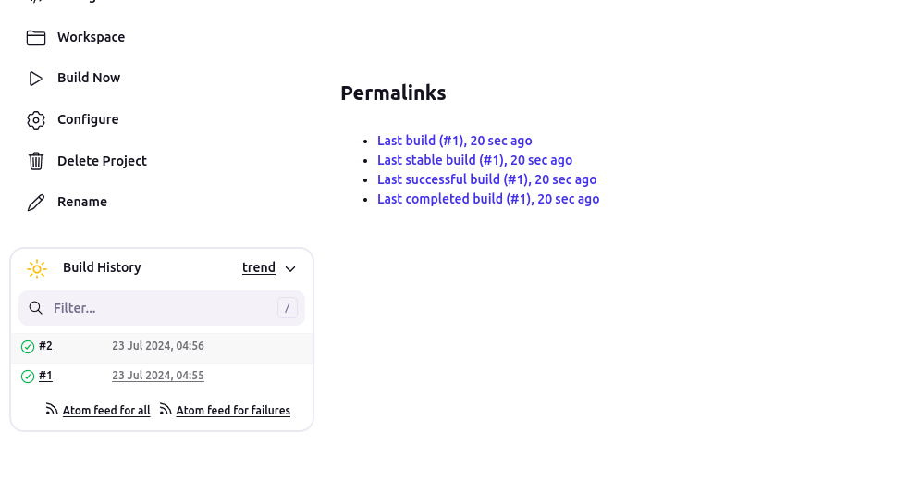

**Step7 : If you want to see the console output then go to**

